Assume (verb)
Definition: accept without proof (verification)
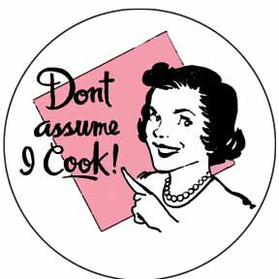
Just because I’m a woman, don’t assume that I can cook!
I assume that you have grasped the basics of reading.
Don't assume that my kindness is a sign of weakness.
I assume by the look on your face, that you are happy with your salary increase.

