Complicate (verb)
Definition: to make difficult
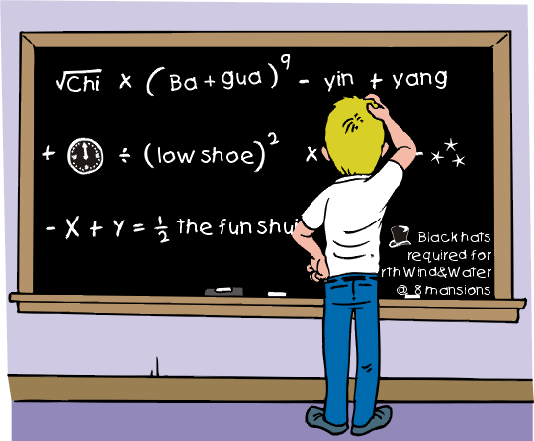
Algebra math problems can be complicated.

His recovery from the operation was complicated by an allergic reaction.

The bad weather complicated our vacation plans.

Difficult words complicate the spelling test.

