Convert (verb)
Definition: to change or transform
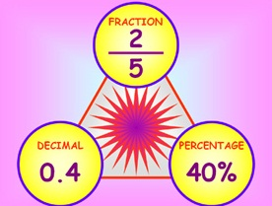
The sofa can be converted to a bed.
In math you learned how to convert a fraction into a decimal.
I converted my favorite jeans into shorts.

