CYCL (Greek) Means: circle
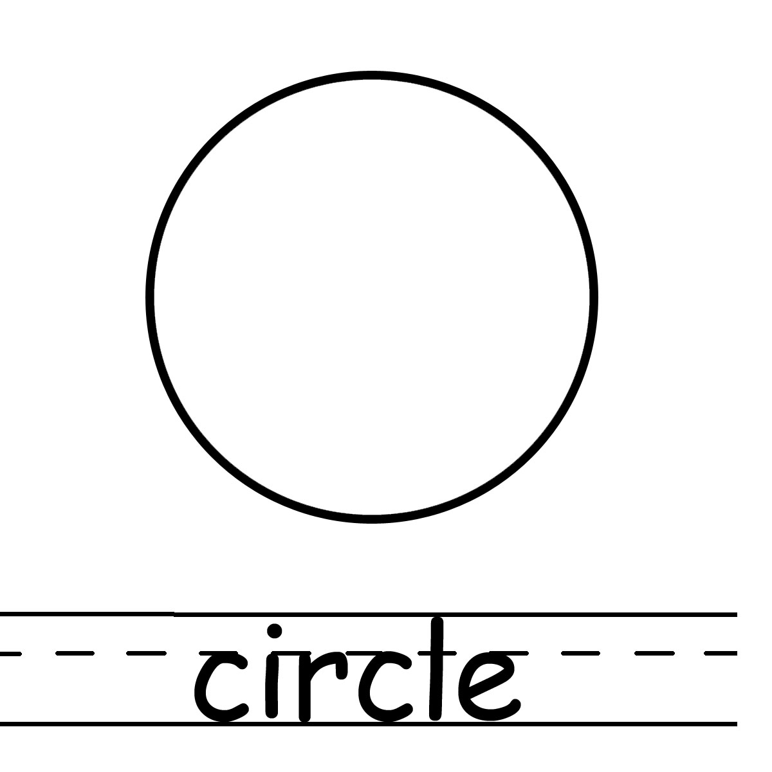

Example words:
The cyclone demolished the country of Hati.

The water cycle describes the continuous movement of water above and below the Earth’s surface.

Example words:

