Exposition (noun)
Definition: The exposition is the part of a book that sets the stage for the drama to follow: it introduces the setting, characters, and circumstances at the story’s beginnings
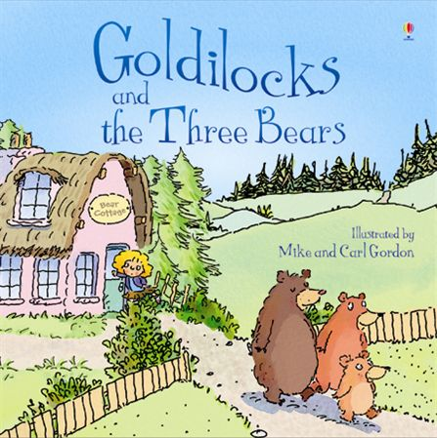
Example:
“Once upon a time there were three little bears, a mama bear, a papa bear, and a baby bear. They lived deep in the forest, far away from any people. One morning, mama bear decided to treat her family to a hot serving of porridge.”
“On a hot summer day in Philadelphia, the wily beggar Bob was looking for a hot dog..."

