Replicate (verb)
Definition: to make an exact copy of, reproduce

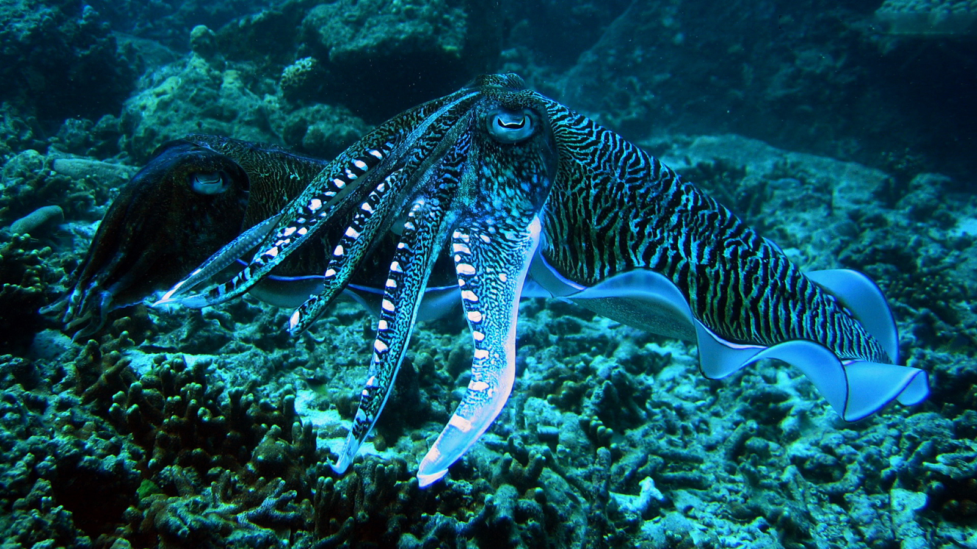
The curious cuttlefish was overlooked by the hungry shark because it naturally replicated the colors of the ocean floor.
The scientific community cannot replicate his results.
Controlled burning is not supposed to replicate wildfire conditions.

