Resolution (noun)
Definition: the main conflict of the story has been resolved.

Examples: 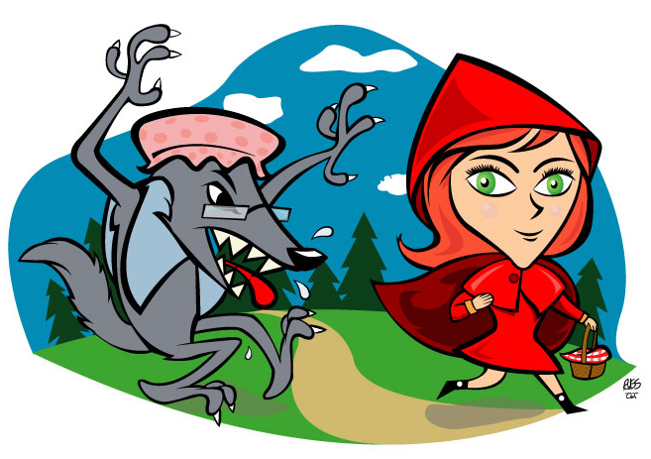
“Little Red Red Riding Hood carried until the great trough was quite full. Then the smell of the sausages reached the wolf, and he sniffed and peeped down, and at last stretched out his neck so far that he could no longer keep his footing and began to slip, and slipped down from the roof straight into the great trough, and was drowned. But Red Riding Hood went joyously home, and no one ever did anything to harm her again. “
“That’s enough!” she exclaimed, raising her magic wand. In a flash, Cinderella appeared in a splendid dress, shining with youth and beauty. Her stepmother and stepsisters gaped at her in amazement, and the ministers said, “Come with us, fair maiden! The Prince awaits to present you with his engagement ring!” So Cinderella joyfully went with them, and lived happily ever after with her Prince.”

